C++ with Mr. Merlis – A First Look at Recursion
Class #12

Recursion refers to repeating the same action in a particular situation such that each time you repeat the action, you are getting closer to solving the problem. Eventually a ‘base case’ should be reached which stops the recursion. In computing terms, recursion is the art of a method calling itself.

// This Mover robot uses recursion to get around a wall, lining up with where it started.
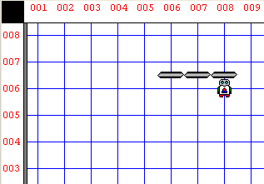
class Mover : Robot
{
void getAroundWall();
void getAround();
Boolean rightIsBlocked();
void turnRight();
};

void Mover :: turnRight()
{
loop(3)
{
turnLeft();
} // turn right
}

Boolean Mover :: rightIsBlocked()
{
turnRight();
if(frontIsClear() )
{ // not blocked
turnLeft();
return false;
} // not blocked
TRACING THE RECURSIVE CALL

@ 6, 8 | @ 6, 7 | @6, 6 | @ 6,5
void Mover::getAround()  {  if(rightIsBlocked())  {  move();  getAround();  move();  }  else  {  turnRight();  move();  turnRight();  }  } | void Mover::getAround()  {  if(rightIsBlocked())  {  move();  getAround();  move();  }  else  {  turnRight();  move();  turnRight();  }  } | void Mover::getAround()  {  if(rightIsBlocked())  {  move();  getAround();  move();  }  else  {  turnRight();  move();  turnRight();  }  } | void Mover::getAround()  {  if(rightIsBlocked())  {  move();  getAround();  move();  }  else  {  turnRight();  move();  turnRight();  }  }

else // // blocked!
{
turnLeft();
return true;
}
}

void Mover :: getAroundWall()
{
turnLeft();
getAround();
turnLeft();
}

void Mover :: getAround()
{
if(rightIsBlocked())
{
move();
getAround();
move();
}
else
{
turnRight();
move();
turnRight();
}
}

task
{
Mover Alex(6, 8, North, 0);
Alex.getAroundWall();
}

